Opportunity | Sponsor Amount | Sponsored By
Food Breaks:
Monday (Soda, water & snacks) | $2,000.00
Tuesday (Soda, water & snacks) | $2,000.00
Monday Box Lunch/ half sponsorship | $4,000.00/$2,000.00
Palliative Pre-Conference Speakers | $2,000.00
Pre-Conference Hospice Speakers | $2,000.00
Photographer | $1,000.00
Reception Decorations | $1,000.00
Photo Booth (for Game Night) | $1,500.00
Tuesday Meals:
Breakfast – in Exhibit Hall/ half sponsorship | $3,000.00/$1,500.00
Lunch – in Exhibit Hall/ half sponsorship | $5,000.00/$2,500.00
Exhibit Hall Decorations | $1,000.00
Exhibitor Reception | $5,000.00
Breakout Session Sponsorships (Multiple available) | $500.00
Keynote Speakers:
Monday, Opening Speaker | $3,000.00
Tuesday, Opening Speaker | $3,000.00
Monday Night Game Night | $2,000.00
Registration Bags | $2,000.00
Reception Entertainment/ Reception for all attendees | $1,500.00
Room Direction Signs | $ 500.00
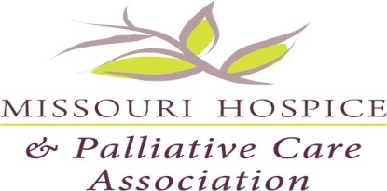

2024 Midwest Regional Conference on Palliative and End of Life Care

Springfield Missouri
Opportunities for Sponsorship

- We will have a Silent Auction at Conference. Please participate by filling out the MHPCA Silent Auction Form. Show your support by donating something fun for attendees to bid on.
- MHPCA will be having a Homeless Veteran’s Drive for the Springfield area at Conference. Please see flyer for more details.
- There is advertising space available for the 2024 Midwest Regional Conference on Palliative and End of Life Care final program. Please contact us at info@missourihospice.org for more information.
Larger sponsorships may be sponsored in part.
Please remember many other opportunities exist and we are not limited to the sponsorships above. Please contact us at info@missourihospice.org if you are interested in becoming a member sponsor or for more information about sponsorships.

